

**PRATHMESH PATIL**

**A71004819033**

**BCA SEM4**

**Cyber Security**

AMITY UNIVERSITY MAHARASHTRA

Amity Institute of Information Technology

This is to certify that Mr. Prathmesh Patil is a Bonfire student of Amity Institute of Information Technology, at Amity University Maharashtra and he has done the project work titled “Cyber Security” at Amity University Mumbai as prescribed by AIIT, AUM in partial fulfilment of the requirement of BCA Program for the academic year 2021-22.

Teacher’s signature :-

**Index**

|  |  |  |
| --- | --- | --- |
| Index No | Experiments | Page no |
| 1 | Chmod commands | 3 |
| 2 | Wireshark tool | 5 |
| 3 | Nmap tools | 6 |
| 4 | Dmitry tools | 14 |
| 5 | Netstat tools | 19 |
| 6 | Arpwatch tools | 23 |
| 7 | Case study | 24 |

**Experiment 1**

**Aim:-** Use of chmod commands.

**Scenario:-**

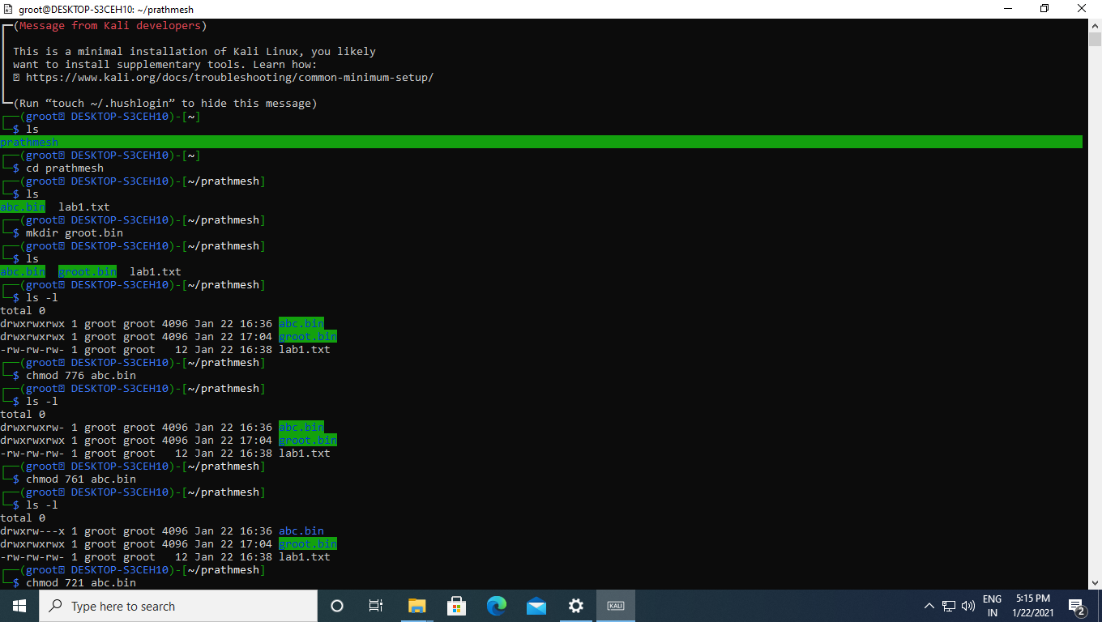

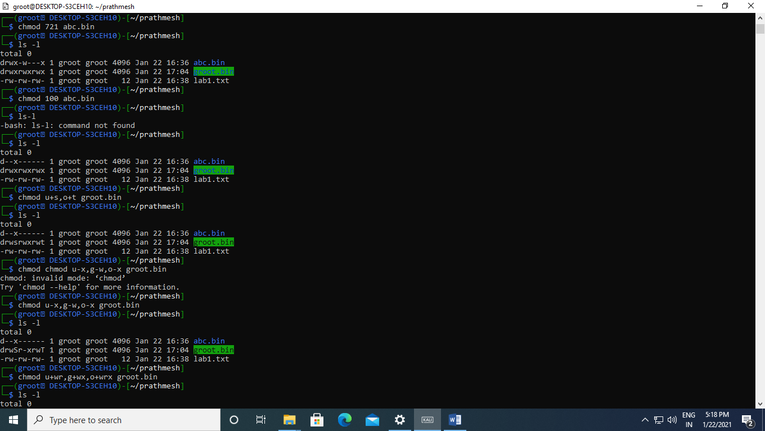

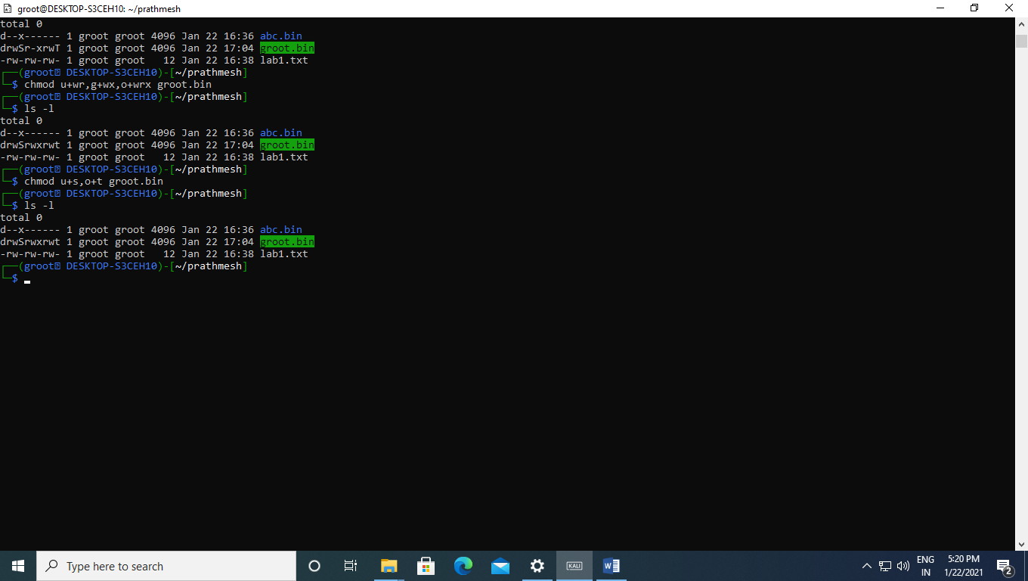

**Experiment 2:-**

**Aim:-** Use of Wireshark to track packets.

**Scenario:-**

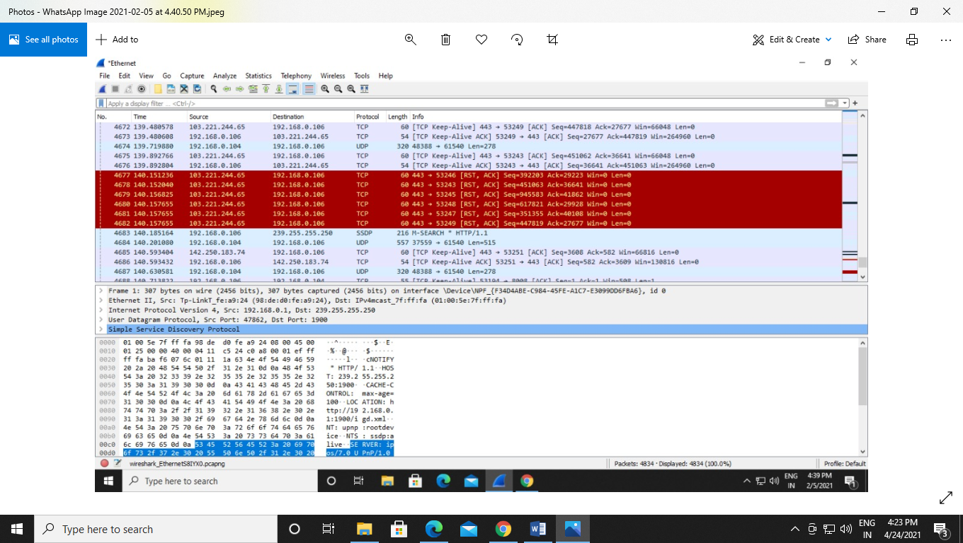

**Experiment 3**

**Aim:-** Download and install nmap. Use it with different options to scan open ports, perform OS fingerprinting, do a ping scan, tcp port scan, udp port scan, etc.

**Scenario:-**

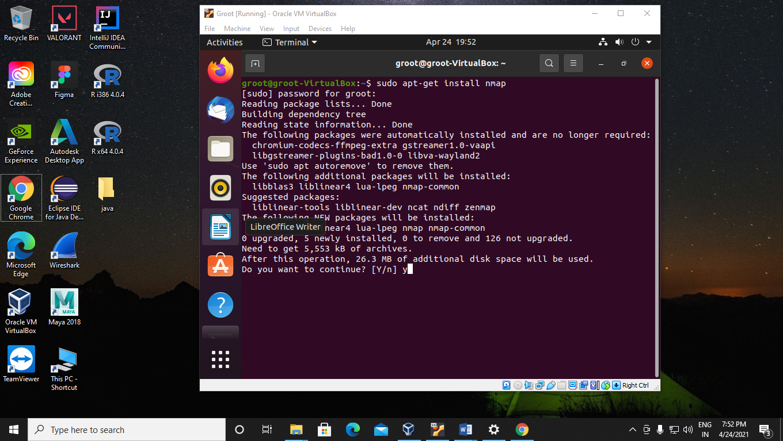

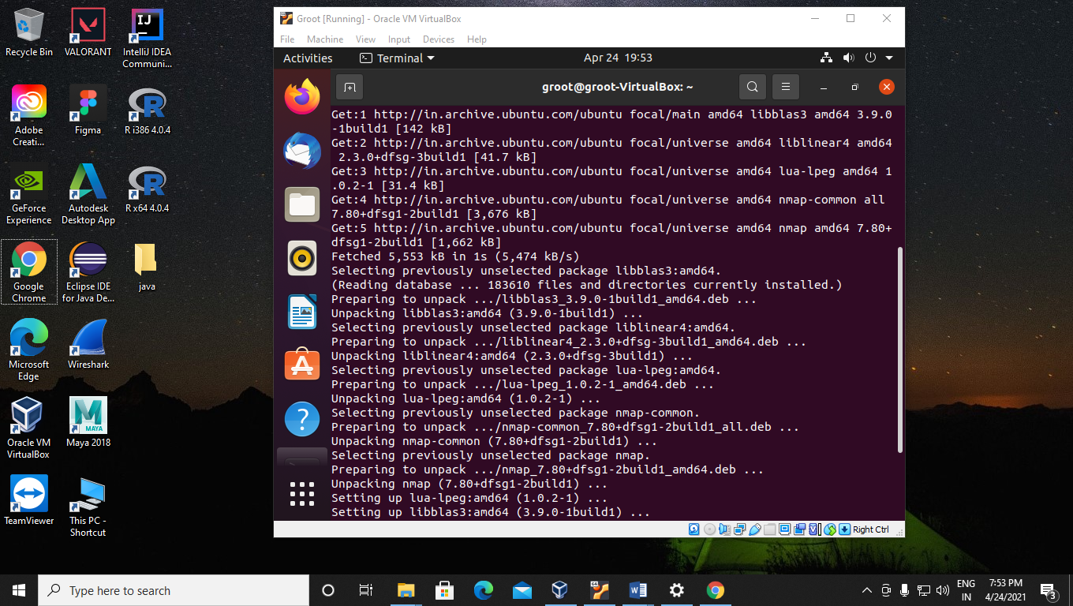

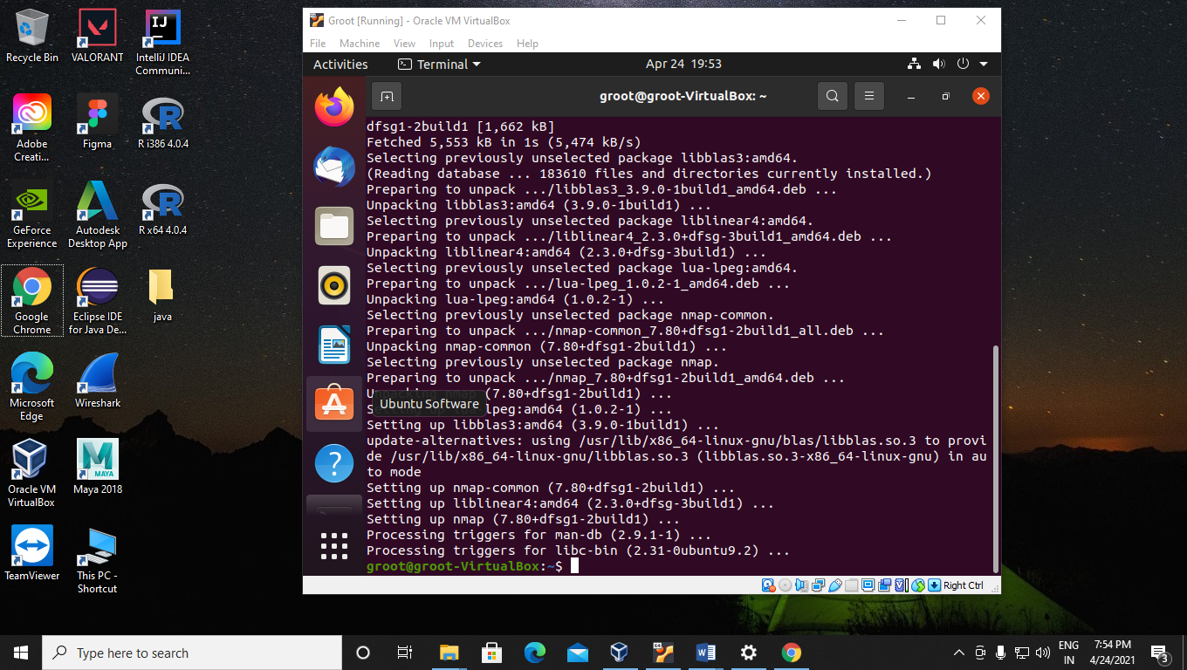

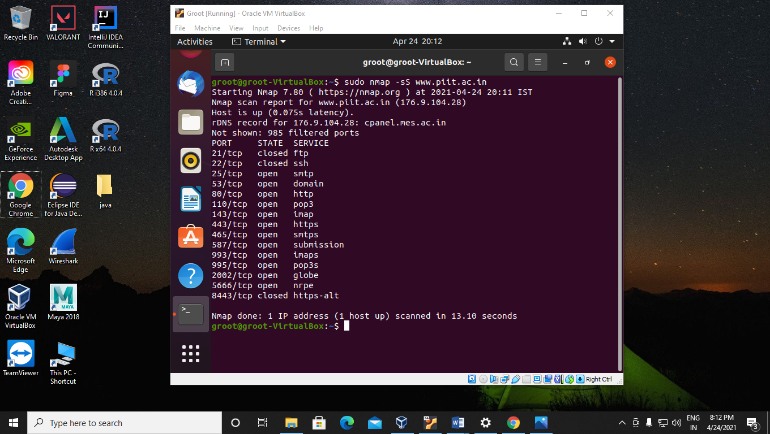

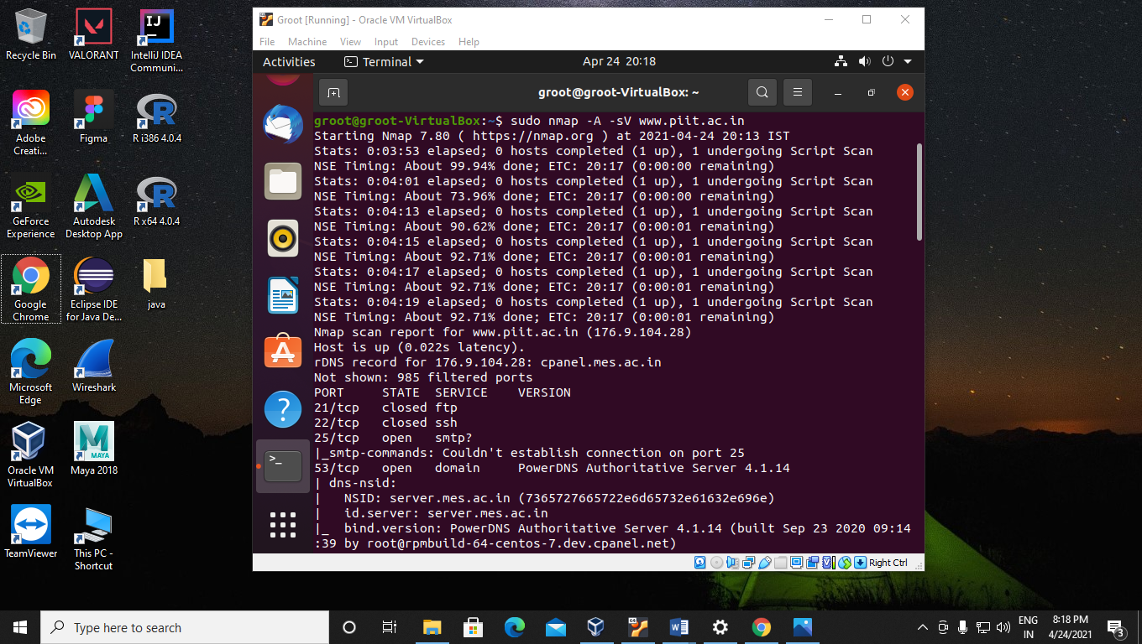

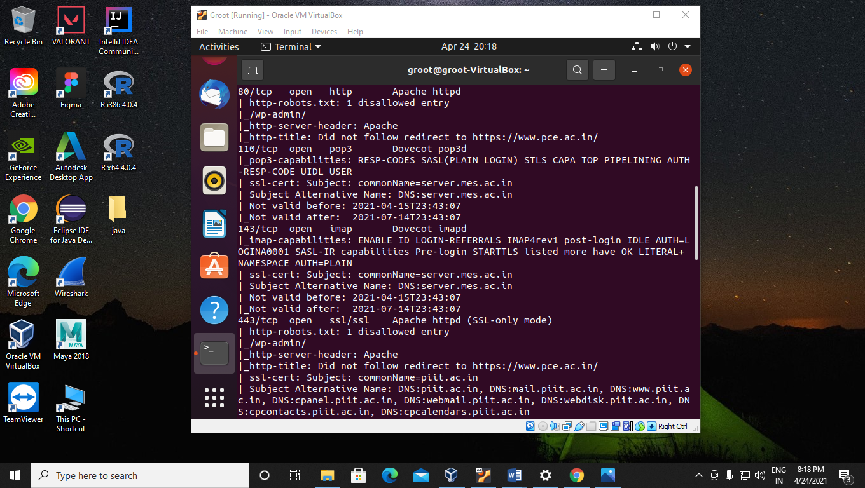

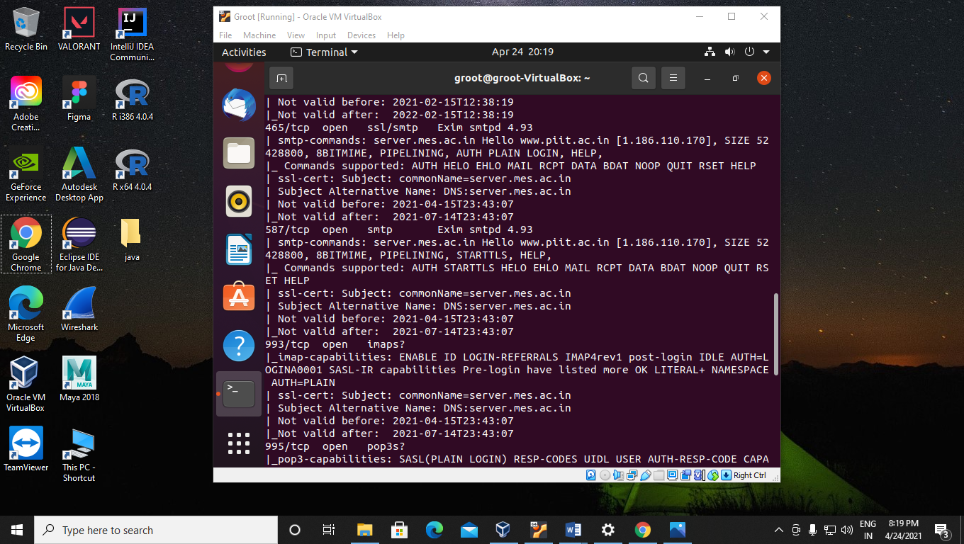

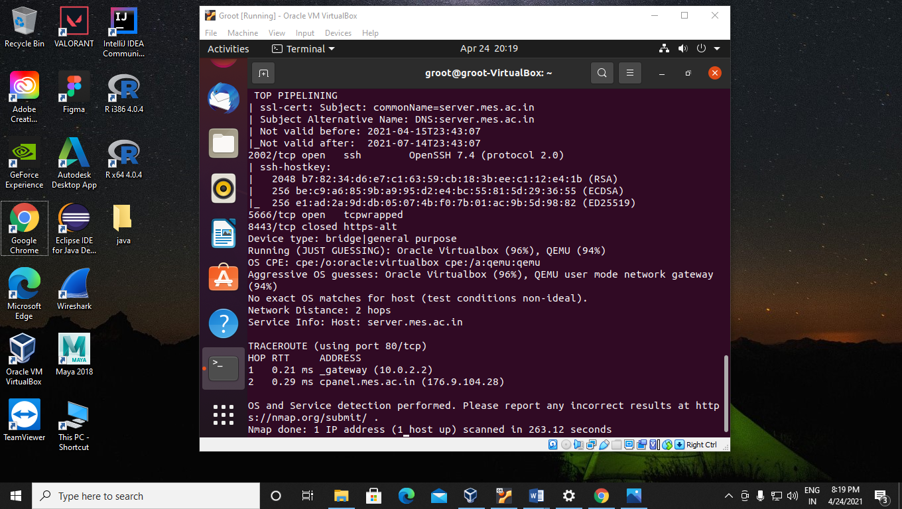

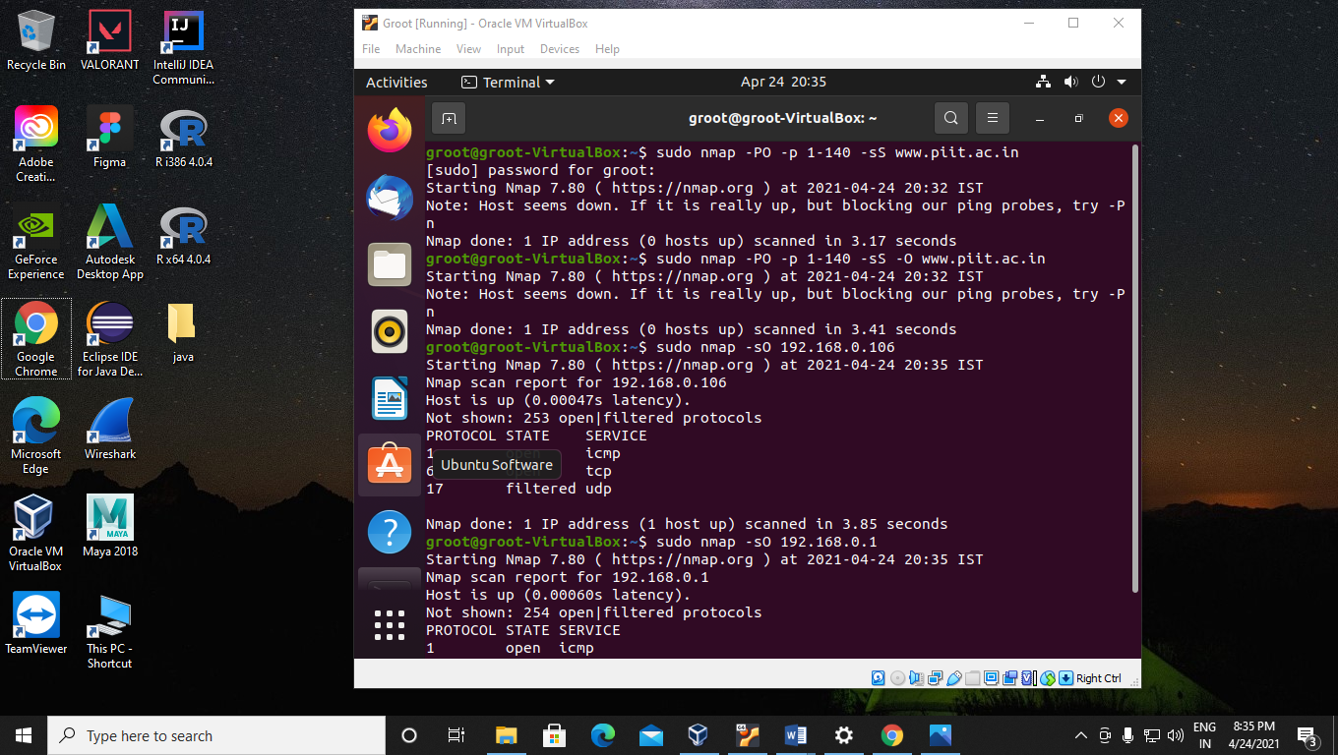

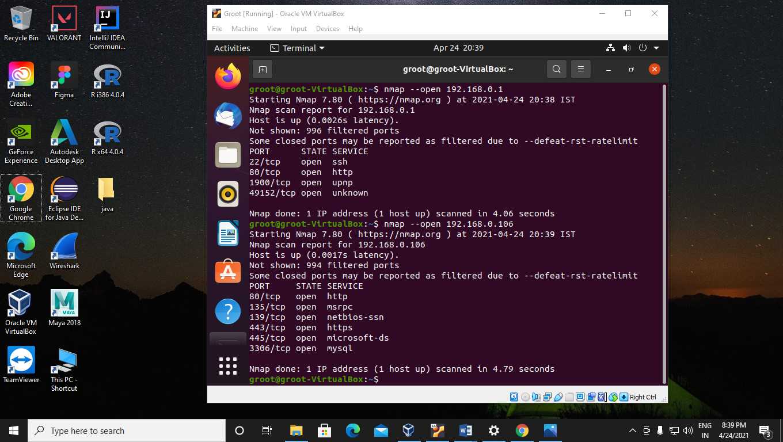

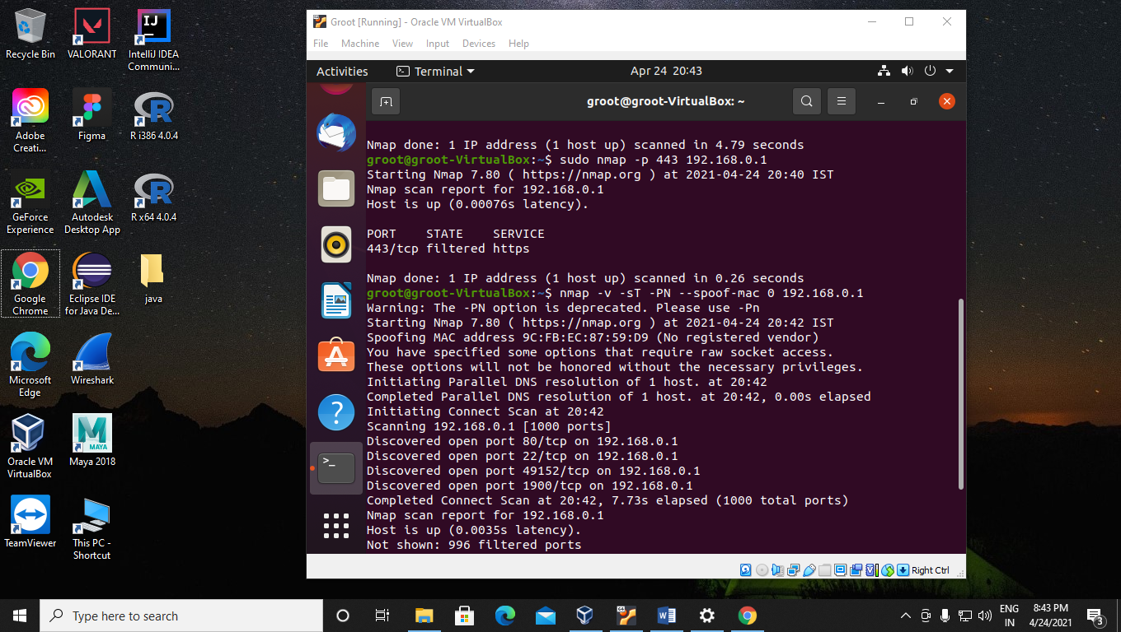

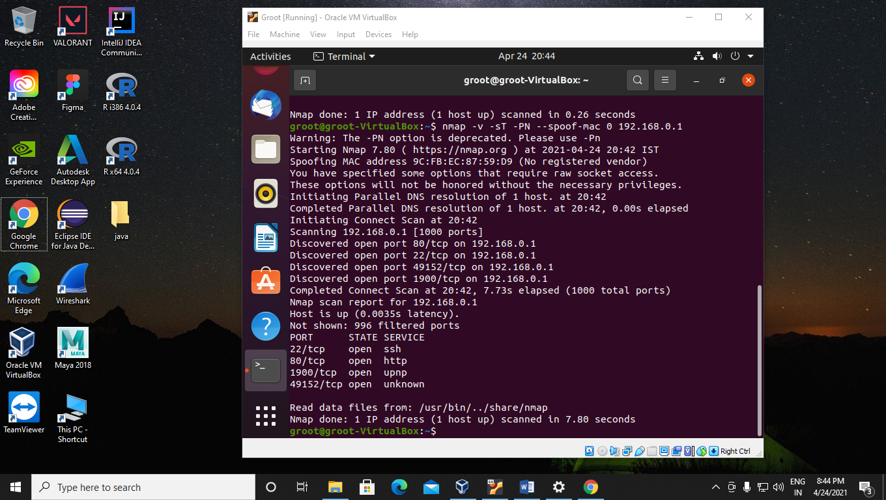

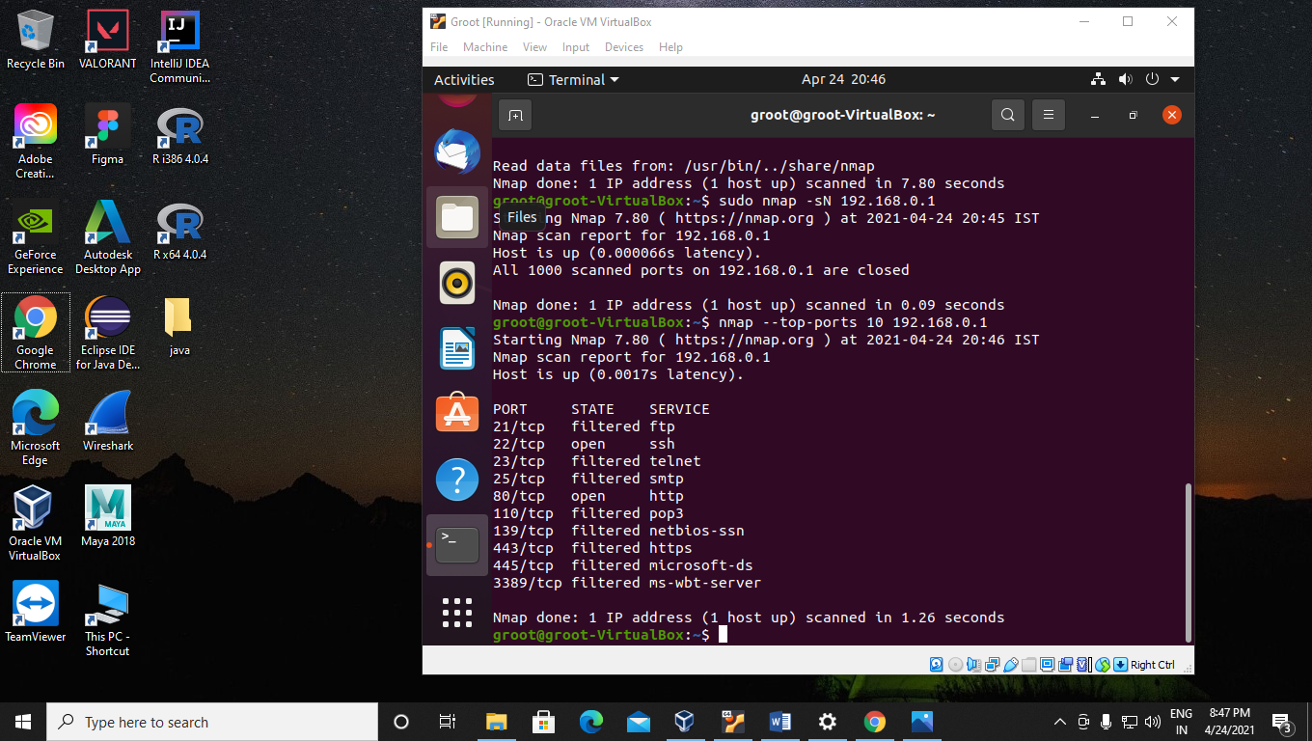

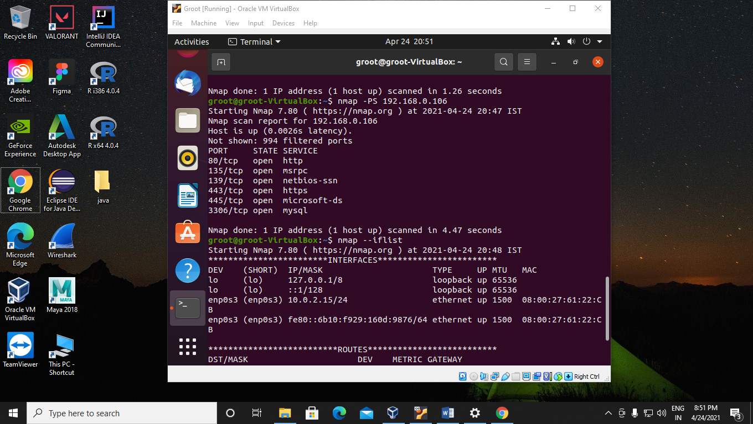

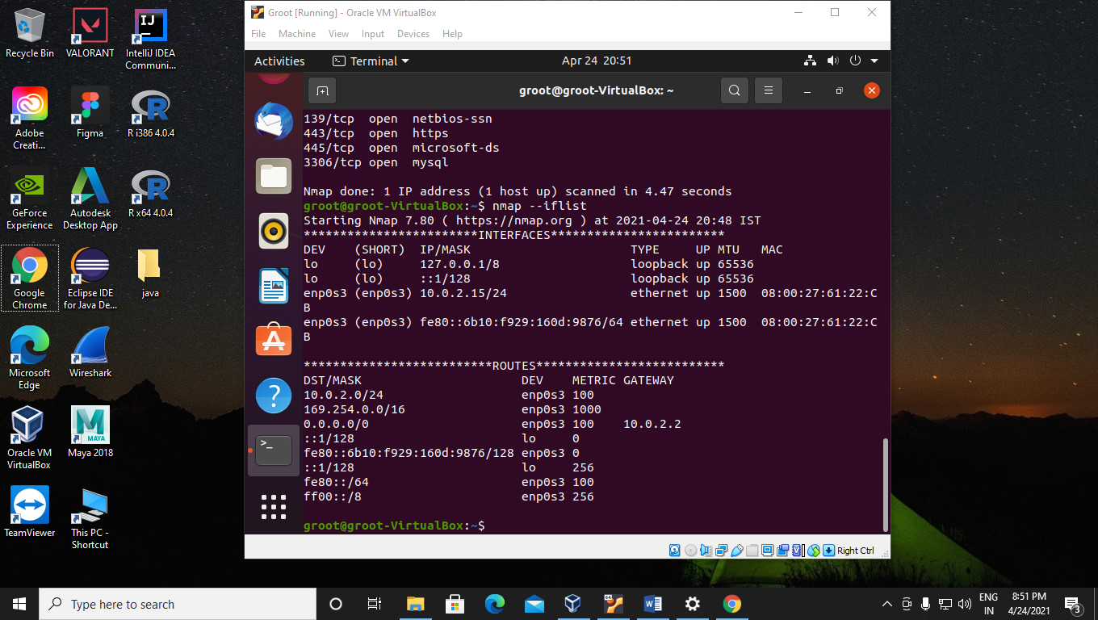

**Experiment 4**

**Aim:-** Use of Dmitry tools.

**Scenario:-**

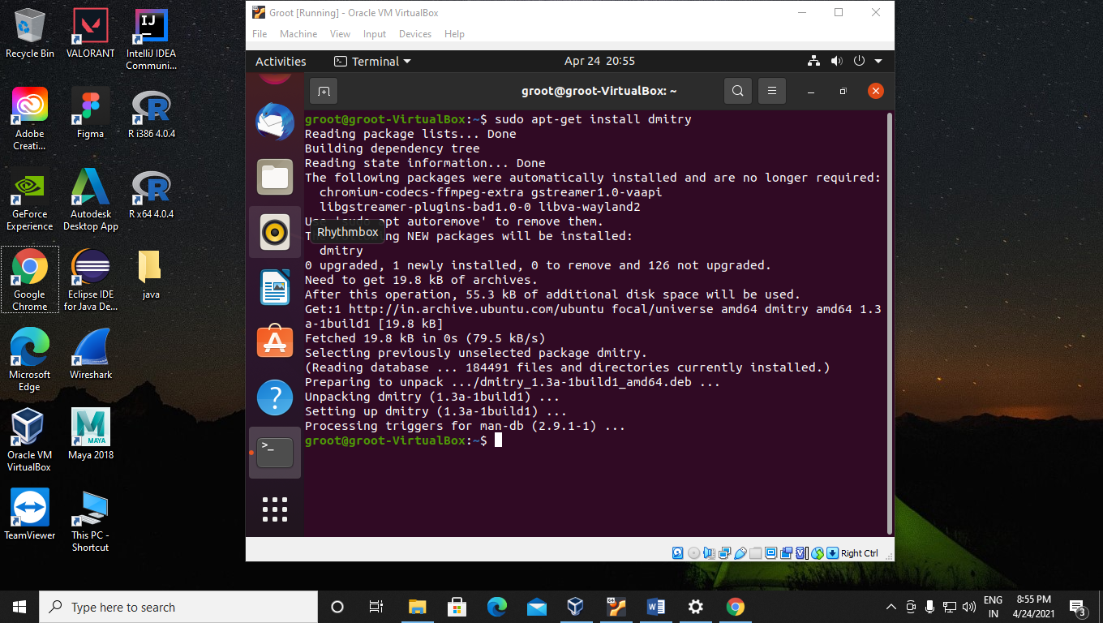

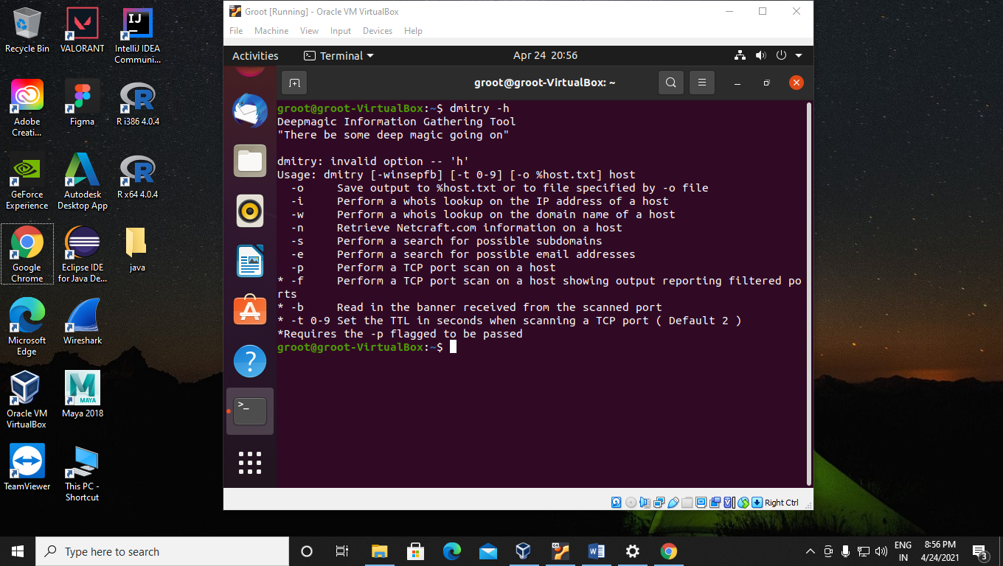

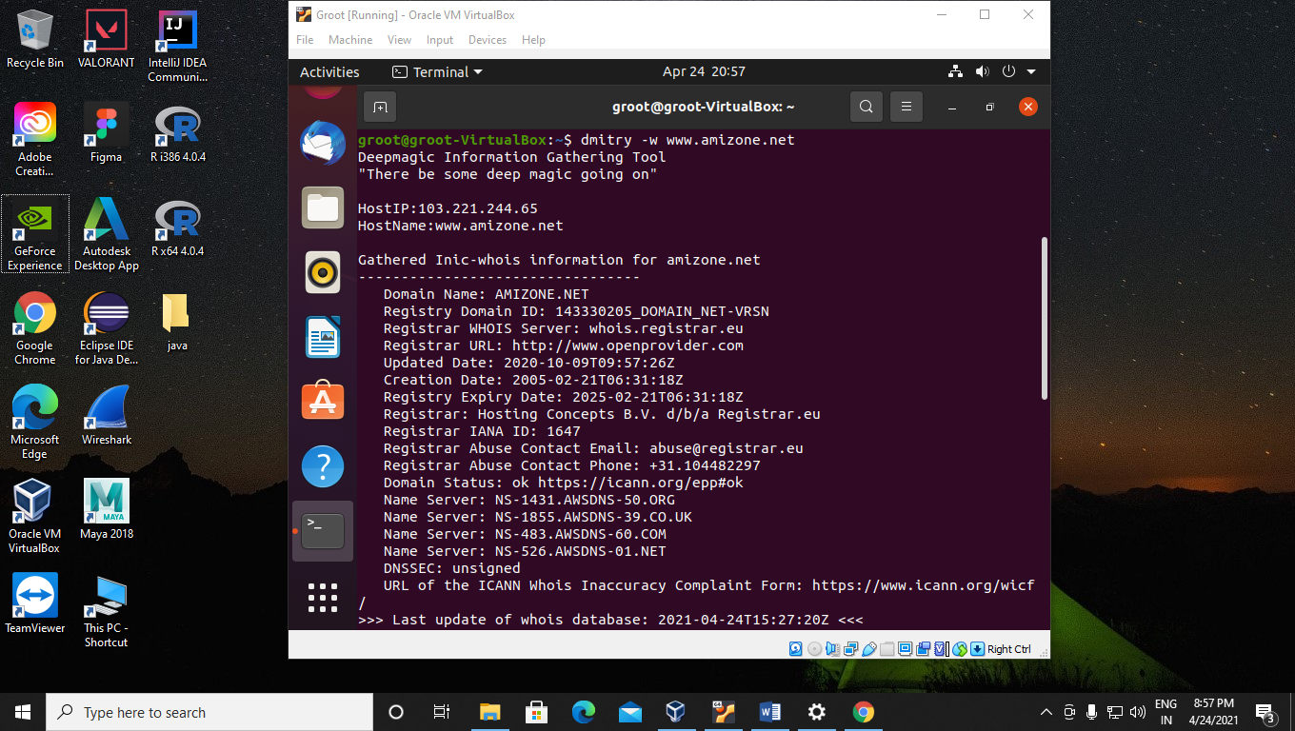

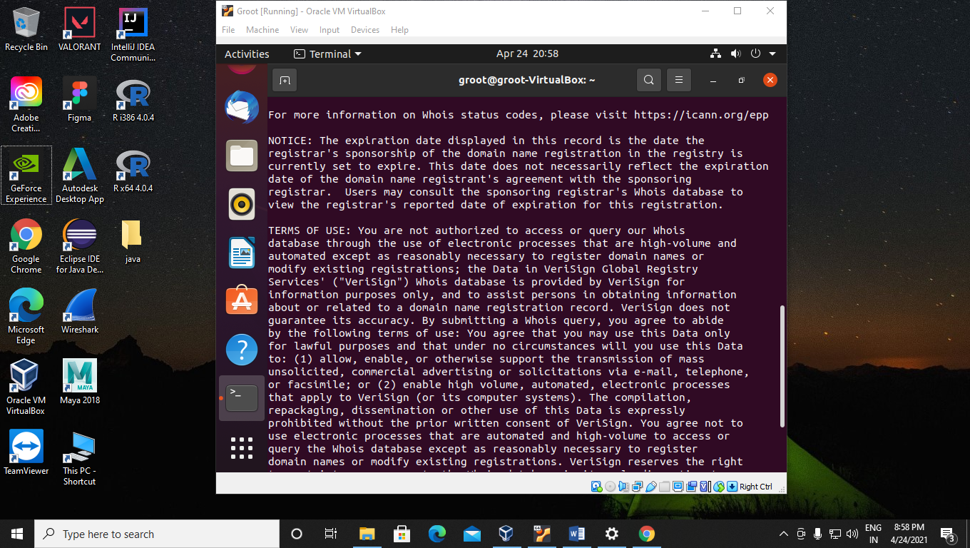

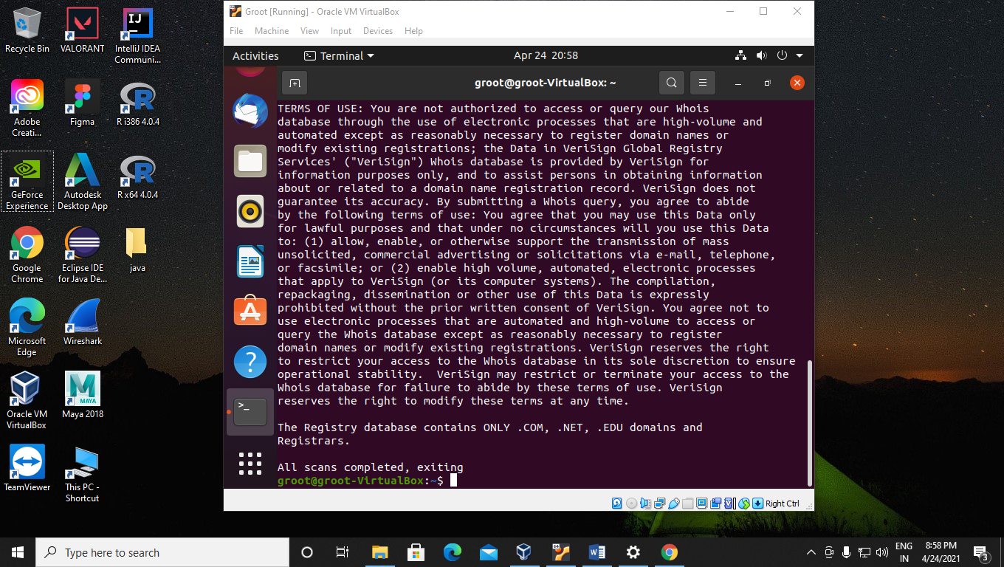

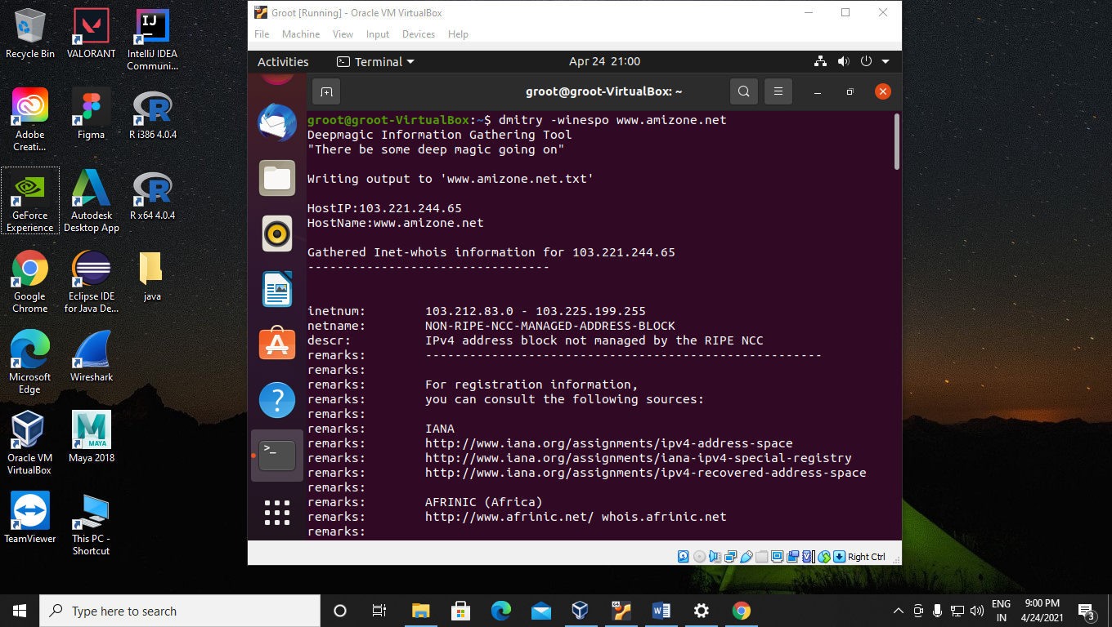

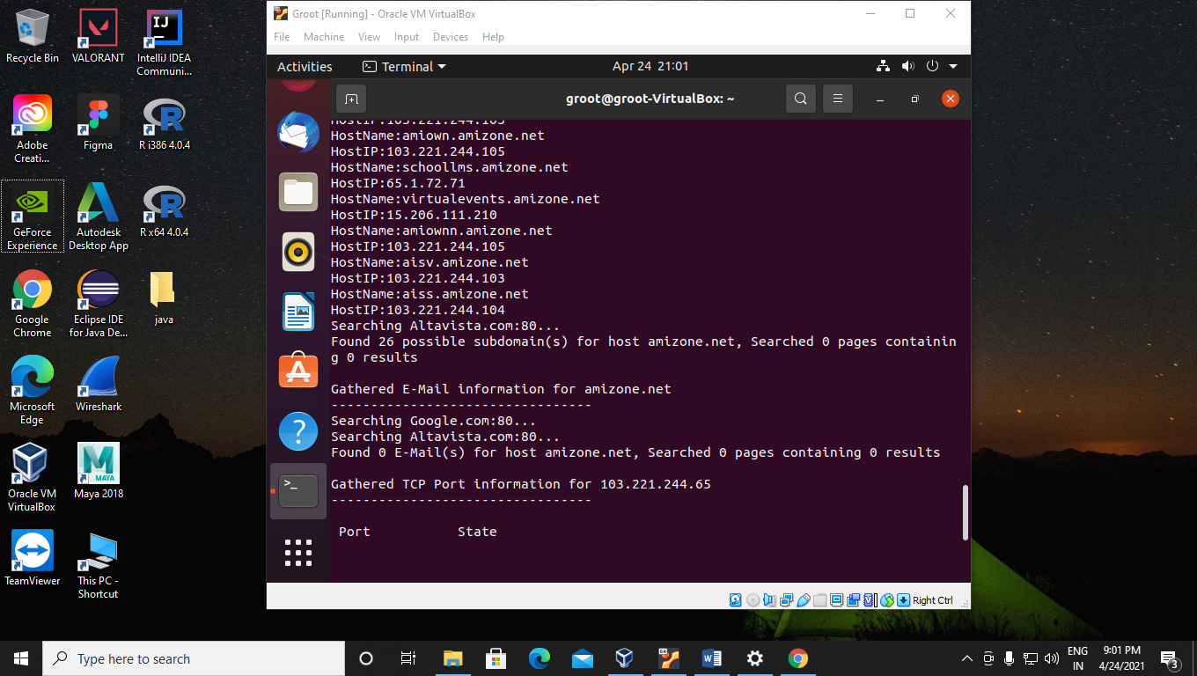

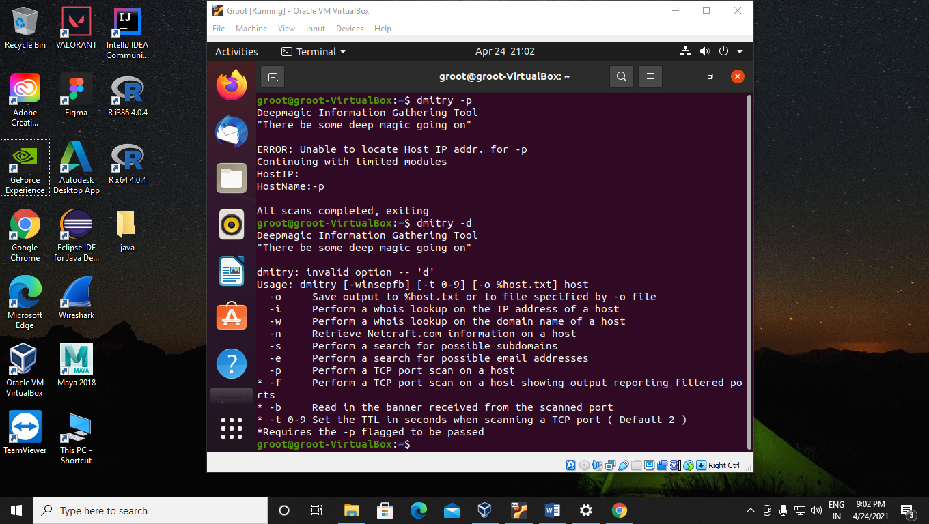

**Experiment 5**

**Aim:-** Use of netstat tool.

**Scenarios:-**

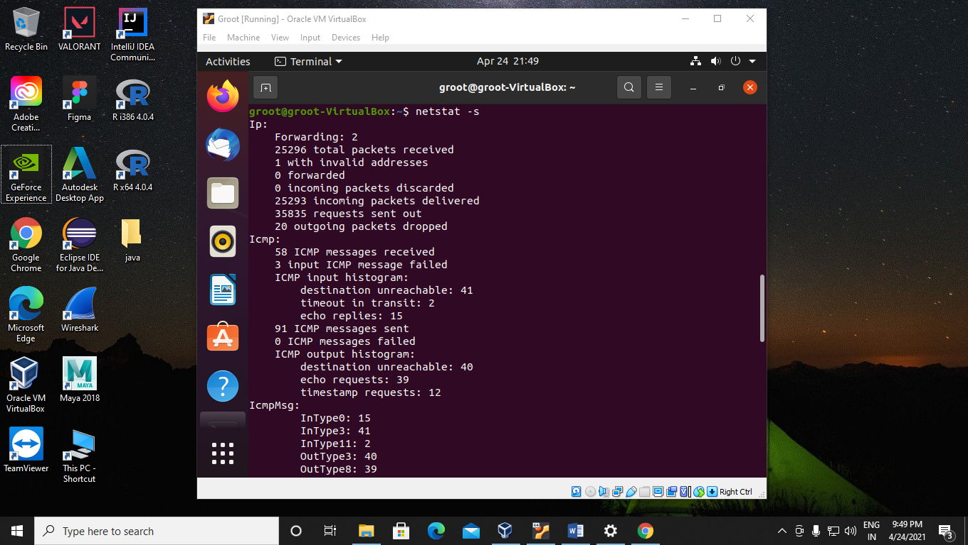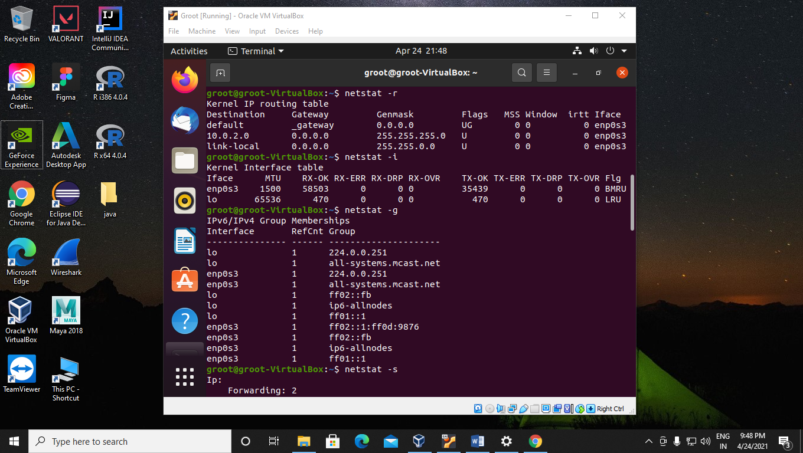

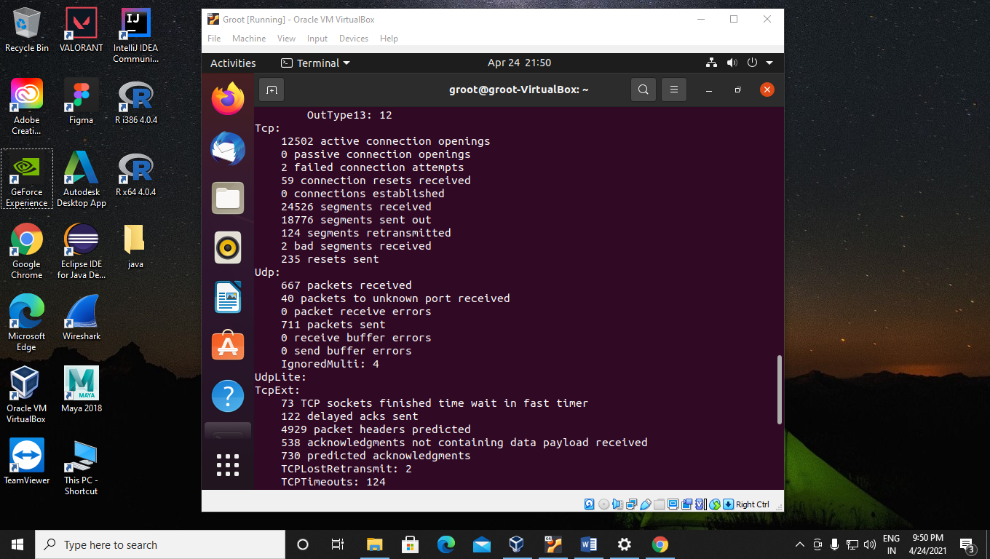

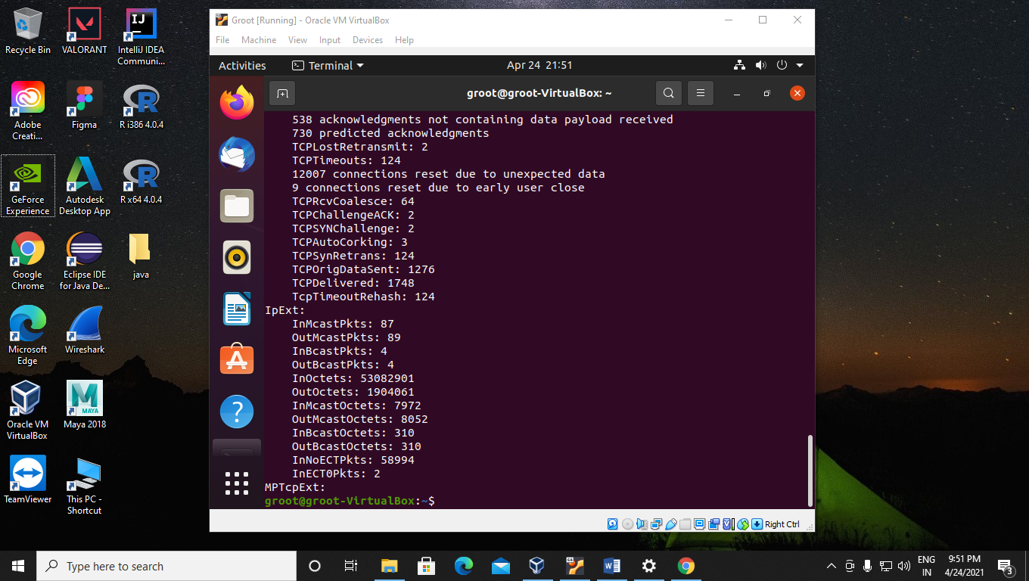



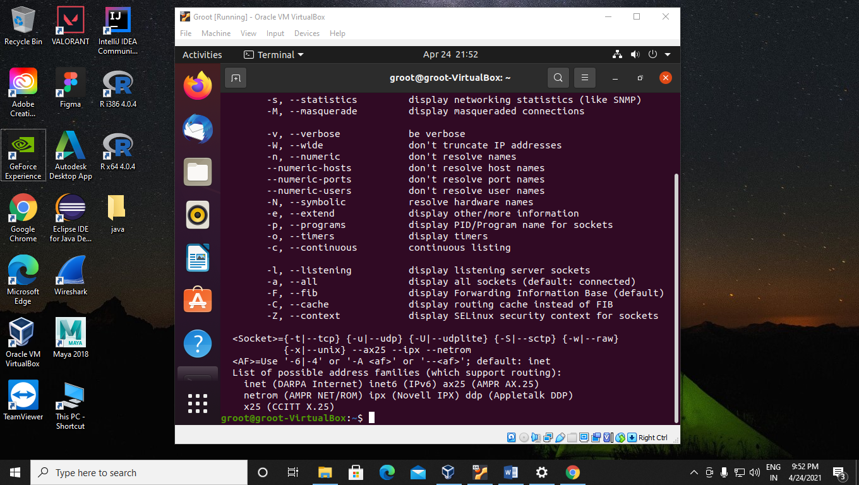

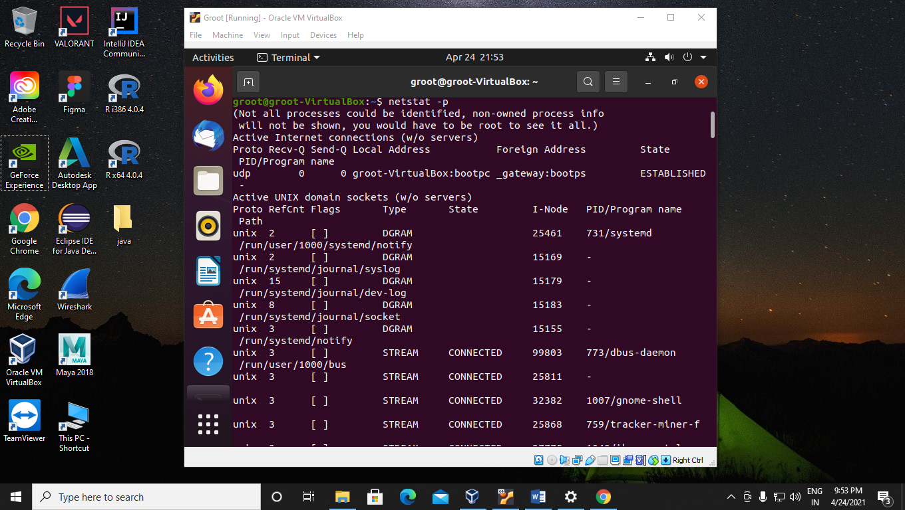

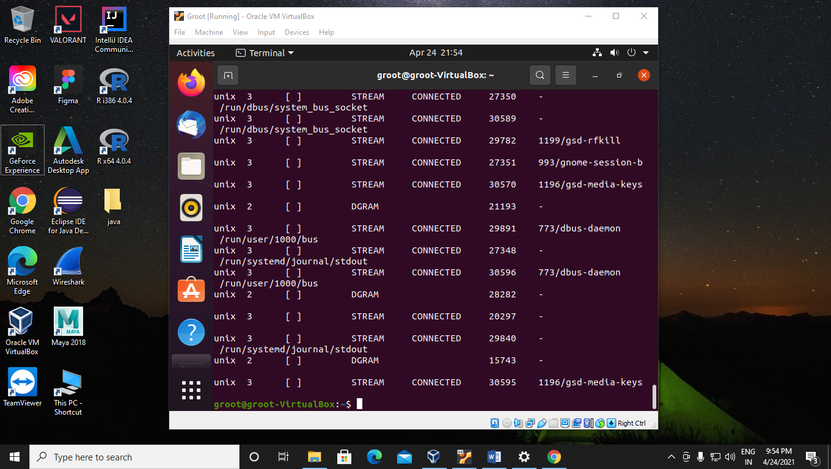

**Experiment 6**

**Aim:-**Use of Arpwatch tools.

**Scenario:-**

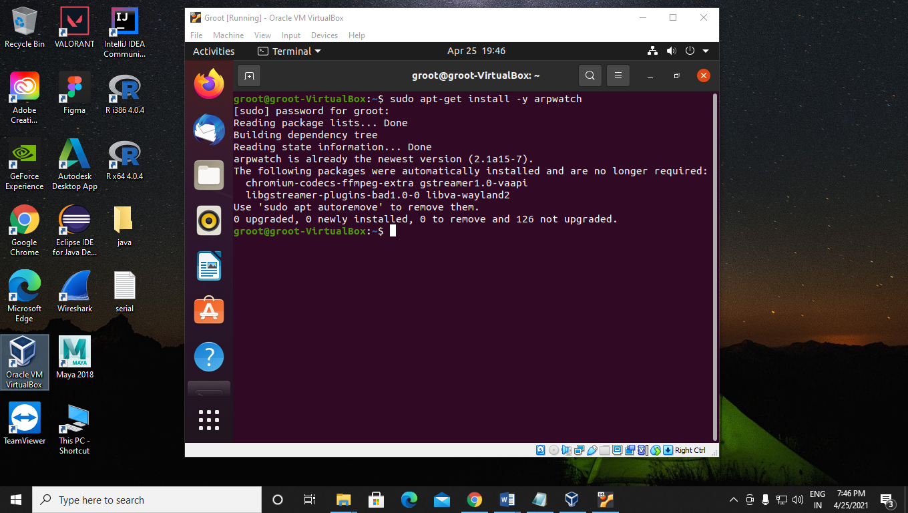

**Case Study**

Password Attack

Prathmesh Patil

A71004819033

BCA SEM 4

Amity University

[Title Here, up to 12 Words, on One to Two Lines]

In the world of the internet, millions of User accounts are created every day and so are their passwords, being an essential medium to access a user account. Strong passwords are considered as the first defence against password attacks.

According to the 2019 Data Breaches report by Verizon 29% of all the breaches involved the use of stolen credentials due to which many of the tech companies are making a push towards Non-password logins by making use of other technologies like biometrics. As a result, it does not only reduce the risk of passwords but also reduces the prevalence of password attacks.

Password attacks can be done ethically or criminally. An ethical hacker is usually someone employed by a company to test the security of various account passwords, to lessen the probability of being hacked. On the other hand, a cyber-criminal performs a password attack to gain entry into systems for monetary or other incentives.

# Methodology

In this section I have collected some valuable information about some password attacks perform by some employee of company to test security of various accounts passwords and by hacker and also a list of some various software which are came to use to perform password attacks.

There are many password cracking software tools, but the most popular are Aircrack, Cain and Abel, John the Ripper, Hashcat, Hydra, DaveGrohl and ElcomSoft. Many litigation support software packages also include password cracking functionality. Most of these packages employ a mixture of cracking strategies, algorithm with brute force and dictionary attacks proving to be the most productive.

The increased availability of computing power and beginner friendly automated password cracking software for a number of protection schemes has allowed the activity to be taken up by script kiddies.

**Types of password attacks:-**

There are various forms of Password attacks that affects billions of users and must be known to all the Internet Users in order to avoid any bandit to sneak their data. The most common attacks carried out nowadays are related to cracking passwords, and the most commonly known password attack is only brute-forcing. There are, in fact, other kinds of attacks around passwords that should be known to all the users.

1. **Dictionary attack:-**

An attack that takes advantage of the fact people tend to use common words and short passwords. The hacker uses a list of common words, the dictionary, and tries them, often with numbers before and/or after the words, against accounts in a company for each username. (Usernames are generally pretty easy to determine as they are almost universally based on the names of the employees.)



1. **Brute force:-**

Using a program to generate likely passwords or even random character sets. These attacks start with commonly used, weak passwords like Password123 and move on from there. The programs running these attacks usually try variations on upper and lowercase characters, as well.



1. **Traffic interception:-**

In this attack, the cyber criminal uses software such as packet sniffers to monitor network traffic and capture passwords as they’re passed. Similar to eavesdropping or tapping a phone line, the software monitors and captures critical information. Obviously, if that information—such as passwords—is unencrypted, the task is easier. But even encrypted information may be decryptable, depending on the strength of the encryption method used.



1. **Man In the Middle:-**

In this attack, the hacker’s program doesn’t just monitor information being passed but actively inserts itself in the middle of the interaction, usually by impersonating a website or app. This allows the program to capture the user’s credentials and other sensitive information, such as account numbers, social security numbers, etc. Man in the middle (MITM) attacks are often facilitated by social engineering attacks which lure the user to a fake site.

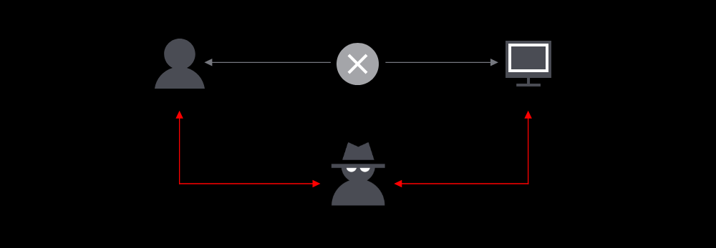

1. **Key logger attack:-**

A cyber criminal manages to install software that tracks the user’s keystrokes, enabling the criminal to gather not only the username and password for an account but exactly which website or app the user was logging into with the credentials. This type of attack generally relies on the user first falling prey to another attack that installs the malicious key logger software on their machine.

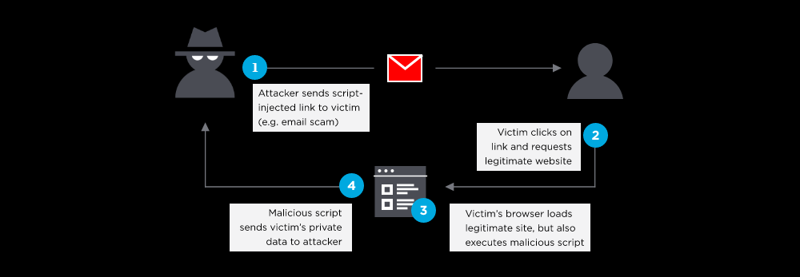

1. **Social engineering attacks:-**

Social engineering attacks refers to a broad range of methods to obtain information from users. Among the tactics used are:

* Phishing—Emails, texts, etc. sent to fool users into providing their credentials, clicking a link that installs malicious software, or going to a fake website.
* Spear phishing—Similar to phishing but with better crafted, tailored emails/texts which rely on information already gathered about the users. For example, the hacker may know that the user has a particular type of insurance account and reference it in the email or use the company’s logo and layout to make the email seem more legitimate.
* Baiting—Attackers leave infected USBs or other devices in public or employer locations in the hopes they will be picked up and used by employees.
* Quid quo pro—The cyber criminal impersonates someone, like a helpdesk employee, and interacts with a user in a way that requires getting information from them.

### Results:-

In this section the reults of the above mentioned password attacks are collected as a real time incidents which are remarkable attacks done by hackers, for a better way to understand this various password attacks.

On July 16, 1998, CERT reported an incident where an attacker had found 186,126 encrypted passwords. By the time they were discovered, they had already cracked 47,642 passwords.

In December 2009, a major password breach of the Rockyou.com website occurred that led to the release of 32 million passwords. The attacker then leaked the full list of the 32 million passwords (with no other identifiable information) to the internet. Passwords were stored in cleartext in the database and were extracted through a SQL Injection vulnerability. The Imperva Application Defense Center (ADC) did an analysis on the strength of the passwords.

In June 2011, NATO (North Atlantic Treaty Organization) experienced a security breach that led to the public release of first and last names, usernames, and passwords for more than 11,000 registered users of their e-bookshop. The data were leaked as part of Operation AntiSec, a movement that includes Anonymous, LulzSec, as well as other hacking groups and individuals.

On July 11, 2011, Booz Allen Hamilton, a large American Consulting firm that does a substantial amount of work for the Pentagon, had their servers hacked by Anonymous and leaked the same day. "The leak, dubbed 'Military Meltdown Monday,' includes 90,000 logins of military personnel—including personnel from USCENTCOM, SOCOM, the Marine Corps, various Air Force facilities, Homeland Security, State Department staff, and what looks like private sector contractors”. These leaked passwords wound up being hashed with unsalted SHA-1, and were later analyzed by the ADC team at Imperva, revealing that even some military personnel used passwords as weak as "1234".

On July 18, 2011, Microsoft Hotmail banned the password: "123456".

In July 2015, a group calling itself "The Impact Team" stole the user data of Ashley Madison. Many passwords were hashed using both the relatively strong bcrypt algorithm and the weaker MD5 hash. Attacking the latter algorithm allowed some 11 million plaintext passwords to be recovered.

#### Prevention:-

a) Strong passwords are usually the first defense against password attacks. The latest NIST guidelines recommend easy to remember/hard to guess passwords. A good mix of upper and lowercase characters, numbers, and special characters can help. Even better, avoid use of common words and common phrases. Definitely avoid site-specific words (including the name of the app you’re logging into in the password, for instance). NIST also recommends checking passwords against a dictionary of known poor passwords.

b) How to Prevent a Password Attack:-

• Use a Random Character Password Generator that creates and stores encrypted passwords

• Schedule and rotate passwords often

• Use hard to guess passwords with different cased characters, numbers, symbols or unique phrases

• Don’t use common words, like “admin” or “password”

• Avoid using the name of the site in your password

• Use single sign-on or multi-factor authentication wherever possible

• Use biometric authentication where possible, like fingerprint authentication makes it much harder to be impersonated

• As the saying goes, using a combination of upper- and lower-case letters, numbers, symbols (and a retina scan, jk), might not protect you completely, but it goes a long way in deterring hackers.

c) Employee education is also important. One of the best defenses against social engineering tactics is teaching users the techniques hackers use and how to recognize them.

d) Strong passwords and education really aren’t enough these days, though. Computing power allows cyber criminals to run sophisticated programs to obtain or try massive numbers of credentials. That’s why NIST also recommends not relying on passwords alone. Specifically, companies should adopt tools like single sign-on (SSO) and multi-factor authentication (MFA), also known as two-factor authentication.

e) SSO helps eliminate passwords by letting employees login to all their apps and sites with just one set of credentials. Users only need remember one, strong password. MFA requires an additional piece of information when the user logs in, such as a pin generated by an application like OneLogin Protect or fingerprint authentication. This additional piece of information makes it far more difficult for cyber criminals to impersonate a user.

f) One method of preventing a password from being cracked is to ensure that attackers cannot get access even to the hashed password. For example, on the Unix operating system, hashed passwords were originally stored in a publicly accessible file /etc/passwd. On modern Unix (and similar) systems, on the other hand, they are stored in the shadow password file /etc/shadow, which is accessible only to programs running with enhanced privileges (i.e., "system" privileges). This makes it harder for a malicious user to obtain the hashed passwords in the first instance, however many collections of password hashes have been stolen despite such protection. And some common network protocols transmit passwords in cleartext or use weak challenge/response schemes.

g) Another approach is to combine a site-specific secret key with the password hash, which prevents plaintext password recovery even if the hashed values are purloined. However privilege escalation attacks that can steal protected hash files may also expose the site secret. A third approach is to use key derivation functions that reduce the rate at which passwords can be guessed.

h) Another protection measure is the use of salt, a random value unique to each password that is incorporated in the hashing. Salt prevents multiple hashes from being attacked simultaneously and also prevents the creation of precomputed dictionaries such as rainbow tables.

i) Modern Unix Systems have replaced the traditional DES-based password hashing function crypt() with stronger methods such as crypt-SHA, bcrypt and scrypt. Other systems have also begun to adopt these methods. For instance, the Cisco IOS originally used a reversible Vigenère cipher to encrypt passwords, but now uses md5-crypt with a 24-bit salt when the "enable secret" command is used. These newer methods use large salt values which prevent attackers from efficiently mounting offline attacks against multiple user accounts simultaneously. The algorithms are also much slower to execute which drastically increases the time required to mount a successful offline attack.

##### **Conclusion:-**

Based on this password attacks hackers may use to obtain credentials, practicing smart password management across the board is the strongest defense against unauthorized network access. Best practices for protecting passwords include:

• Demonstrating and enforcing strong password creation

• Implementing the use of password managers

• Establishing a VPN for remote network access

• Using privileged access management (PAM) software to automate password security

• Educating employees on the characteristics of social engineering schemes

• Switching to an SSO option with multi-factor authentication (MFA)

• Authenticating logins through an app installed on users’ devices

These best practices provide protection against common password attacks and equip users to identify potentially malicious attacks and actions. Continual monitoring of network activity and attack trends can reveal emerging threats, guiding businesses toward better access management tools as new technology becomes available.

So, as far for now there is nothing safe on internet. Automation is taking placed all over the world and it is good but this is modern world where nothing can be safe even if you are browsing the websites can also be a part of some malware activities or it is being spy, So you must be aware of it.

##### **References:-**

1) <https://www.onelogin.com/learn/6-types-password-attacks#:~:text=An%20attack%20that%20takes%20advantage,a%20company%20for%20each%20username>.

2) <https://solutionsreview.com/identity-management/the-top-7-password-attack-methods-and-how-to-prevent-them/>

3) <https://lifars.com/2020/04/types-of-password-attacks/>

4) <https://www.bluevoyant.com/blog/password-attacks-and-prevention>

5) <https://www.identitymanagementinstitute.org/7-hacking-password-attack-methods/>

6) <https://en.wikipedia.org/wiki/Password_cracking>